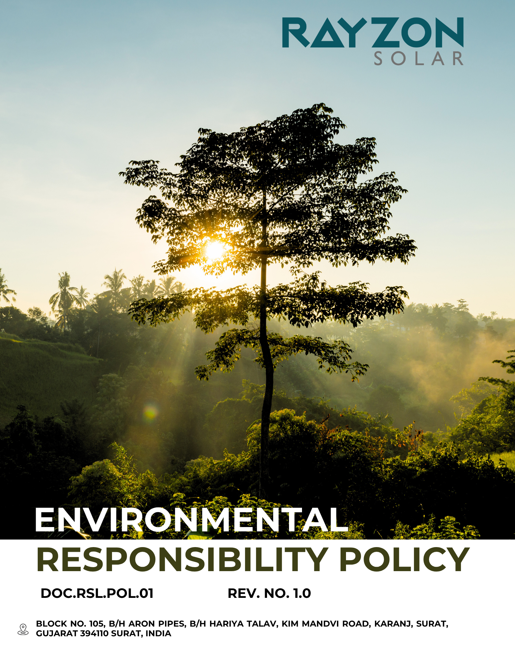
ENVIRONMETNAL RESPONSIBILITY POLICY
Rayzon Solar Ltd.
Effective: April 2024
Approved by the General Manger

Introduction
At Rayzon Solar Limited, environmental responsibility is fundamental to our business philosophy and operations. As a renewable energy company committed to driving a cleaner future, we recognize our duty to minimize environmental impacts across all aspects of our work—from manufacturing to installation and beyond. This policy reflects our ongoing commitment to sustainable practices, pollution prevention, and responsible resource use. We strive to integrate environmental considerations into our decision-making, comply with all relevant environmental laws, and continually improve our performance. Through innovation, employee engagement, and collaboration with stakeholders, we aim to reduce our carbon footprint, manage waste responsibly, and conserve natural resources while delivering high-quality solar solutions. Sustainability is not just a goal—it’s central to who we are.
We actively promote environmental awareness among employees and partners, ensuring that eco-friendly practices are embedded in daily operations, product development, and supply chain management across our facility.

Purpose
- Our approach includes minimizing waste generation, reducing greenhouse gas emissions, conserving water, and promoting the use of sustainable materials.
- We will adopt environmental management systems aligned with ISO 14001 and continuously improve our performance through monitoring, data-driven decisions, and technological innovation.
- To establish clear environmental commitments aligned with Rayzon Solar Limited’s vision for sustainable energy solutions.
- To reduce environmental impact across all operations, including manufacturing, logistics, and product life cycles.
- To ensure compliance with applicable environmental laws, standards, and regulatory requirements.
- To promote responsible use of natural resources and energy efficiency in all business functions.
- To integrate pollution prevention, waste minimization, and emissions reduction strategies into daily practices.
- To foster a culture of environmental awareness among employees, contractors, and supply chain partners.
- To support continuous improvement through regular monitoring, evaluation, and enhancement of environmental performance.
Scope
This policy applies to Factory – 1 (Kim site) of Rayzon Solar Ltd., including all employees, departments, contractors, subcontracted workers, directors, and governance bodies operating within this site. It also extends to any affiliated units or functions directly linked to Factory – 1, as applicable.
Rayzon Solar Limited | Factory – 1 | Block No. 105, B/H Aron Pipes, B/H Hariya Talav, Kim Mandvi Road, Karanj, Surat, Gujarat -394110, India.

Our Commitments and Objectives
Rayzon Solar Ltd. is committed to integrating environmental sustainability into every aspect of our operations and decision-making. We strive to go beyond compliance and actively contribute to a healthier planet. Our commitments include, but are not limited to, the following focus areas:
- Energy Stewardship and Green House Gas Management
- We actively promote the use of renewable and clean energy sources like solar (on-grid & off grid solar systems) across our operations and infrastructure to reduce Scope 2 emissions from carbon-intensive electricity consumption.
- We aim to implement structured energy management practices consistent with ISO 50001 / Energy Conservation Act.
- We aim to keep align our emission accounting practices with internationally accepted frameworks such as the Greenhouse Gas (GHG) Protocol.
- We will set measurable, science-based emission reduction targets and establish a climate transition plan consistent with the goals of the Paris Agreement and India’s national climate commitments.
- Our approach to energy implementation is built on three pillars: technology adoption, organizational integration, and strategic foresight. Our facilities are engineered to accommodate passive design elements, smart grid integration, and energy-optimized machinery, reducing both direct and embodied energy intensity.
- We aim to minimize direct emissions (Scope 1) from company-owned vehicles and generators by adopting electric vehicles and improving fuel efficiency through better route planning and maintenance.
- We aim to prioritize the procurement of energy-efficient equipment and services—such as replacing traditional bulbs with LED lighting—embedding energy considerations into all design and expansion decisions.
- We focus on identifying and implementing practical improvements in energy performance through operational innovation and regular energy audits.
- We are committed to complying with all relevant national and international laws, standards, and voluntary frameworks concerning energy efficiency and consumption.
- We work to raise awareness among employees, contractors, and suppliers about energy efficiency and greenhouse gas (GHG) management through regular training, engagement programs, and collaborative sustainability initiatives.
- Sustainable Materials and Waste Management
- We aim to ensure full compliance with all applicable environmental laws, standards, and regulations governing the generation, handling, and disposal of waste across all operations.
- We commit to fulfilling Extended Producer Responsibility (EPR) by actively recovering post-consumer products such as end-of-life solar modules and e-waste, in accordance with national EPR guidelines and by embedding circularity into our business practices.
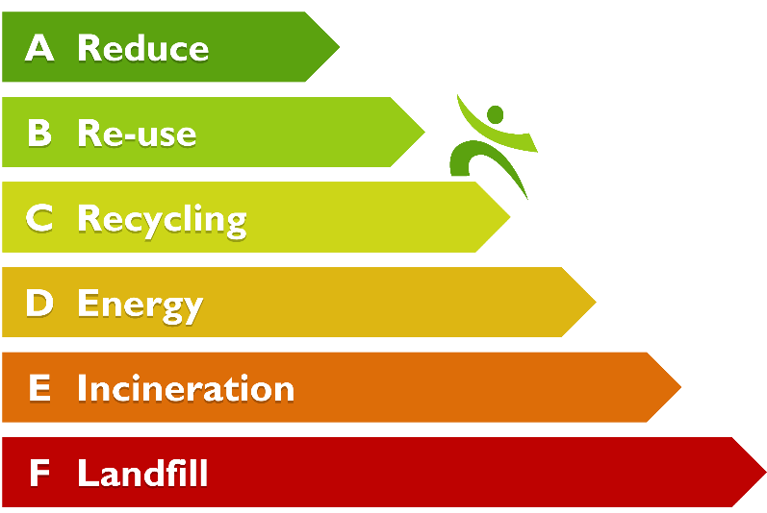
- We strive to institutionalize the 5R Framework (Refuse, Reduce, Reuse, Recycle, Recover) in all operational, procurement, and employee decision-making processes to minimize waste at its source and promote a culture of conscious consumption.

- We adopt Lanxess’ (Lansink's) Ladder as our decision-making tool for waste treatment, prioritizing prevention, reuse, and recycling, and ensuring landfill disposal is the last resort for non-recoverable waste.
- We aim to optimize resource efficiency by reducing reliance on virgin raw materials, increasing the reuse of internal materials, maximizing material recovery at every stage of production, and promoting eco-friendly alternatives wherever possible.
- We commit to driving waste reduction through innovation, investing in new technologies and process improvements that enhance traceability and reduce both hazardous and non-hazardous waste generation.
- We aim to enhance circularity and value recovery by repurposing end-of-life materials through internal recycling, co-processing, and conversion into reusable resources wherever feasible.
- We aim to continue achieving and sustaining Zero Waste to Landfill status by prioritizing recycling, composting, energy recovery, and material reuse to divert waste from landfills.
- Water Efficiency
- We integrate responsible water stewardship across all stages of our operations by minimizing freshwater use, and treating and reusing wastewater.
- We ensure compliance with all applicable state and central water laws, aligning our water practices with the United Nations Sustainable Development Goals, especially SDG 6, to promote sustainable water use practices firm-wide.
- We aim to minimize fresh water consumption in cleaning, cooling, and sanitation through closed-loop systems, dual plumbing, and low-flow fixtures across our facility, including both new and retrofitted office infrastructure.
- We aim to implement real-time monitoring through sensor-based and IoT-enabled water flow meters to track consumption, improve efficiency, and promptly detect leakages or abnormal usage trends at all high water-consuming areas.
- We aim to regularly conduct water audits and integrate the findings into our management review meetings to drive continuous improvement, monitor performance, and optimize resource usage across all departments.
- We promote the safe reuse of treated sewage water for non-potable administrative purposes such as toilet flushing and horticulture, thereby reducing reliance on freshwater and supporting circular water practices.
- We ensure round-the-clock availability of water of the right quality and pressure while maintaining STP infrastructure uptime in full compliance with environmental regulations and operational risk controls.
- We have plant to install and maintain rainwater harvesting systems at our operating site and promote indigenous tree plantation to enhance groundwater infiltration, reduce soil erosion, and support long-term water security in urban areas.
- We avoid non-essential groundwater extraction and proactively assess risks related to climate variability, water scarcity, local demand conflicts, and policy changes through regular vulnerability assessments and mitigation planning.
- We assess climate-related risks such as water scarcity, demand conflicts, and policy changes to safeguard long-term water availability and quality.
- We aim to conduct regular awareness sessions and capacity-building programs for employees, contractors, and relevant stakeholders to promote water conservation, responsible usage, and understanding of site-specific water management practices.
- Environmental Impact from product use
- We aim to design and manufacture solar energy products that consistently deliver clean, renewable power with minimal environmental impact throughout their entire operational lifespan.
- We commit to developing products that minimize harm to the local environment during use by reducing emissions, noise, and ecological disruption.
- We strive to maximize energy conversion efficiency in our solar modules and systems, enabling users to generate more electricity using fewer resources and reducing overall emissions.
- We aim to routinely evaluate the environmental footprint of our solar products during design and development phases to ensure low-impact material selection and eco-efficient functionality.
- We strive to implement comprehensive life cycle assessments for our products, from raw material sourcing to end-of-life disposal, to identify opportunities for reducing environmental impact at every stage.
- We commit to conducting proactive environmental risk assessments for all new products and technologies to identify, mitigate, and manage potential negative impacts on ecosystems and communities.
- We ensure our products are compatible with modern technologies such as energy storage systems, smart meters, and grid integration tools to promote efficient and sustainable energy consumption.
- We commit to supporting end-users with detailed installation guidance, user manuals, and maintenance protocols to optimize energy output and extend product life, reducing environmental degradation.
- We prioritize the use of non-toxic, recyclable, and durable materials in product design to reduce emissions, leakage, and other environmental risks during prolonged use.
- We work toward ensuring that every deployed solar system contributes to climate goals by helping users replace fossil-fuel-based energy sources with clean, reliable alternatives.
- We organize regular awareness sessions and training programs for customers to promote responsible product use, energy efficiency, and understanding of the environmental benefits of solar technology.
- Environmental Impact from product end of life
- We aim to proactively reduce the environmental footprint of our solar products at the end of their lifecycle by embedding eco-design principles that facilitate disassembly, reuse, and recycling of components.
- We are committed to developing and supporting take-back schemes and extended producer responsibility programs that enable the safe and sustainable recovery of materials such as glass, aluminum, and semiconductors from used panels.
- We strive to divert end-of-life solar modules and system parts from landfills by partnering with government-recognized e-waste handlers and certified recyclers to maximize material recovery rates and prevent hazardous waste leakage.
- We ensure that our product end-of-life strategies strictly adhere to all applicable national and international environmental regulations, while adopting best-in-class practices that go beyond basic compliance.
- We promote awareness among customers, distributors, and service teams about the importance of responsible disposal, offering clear instructions and access to collection or recycling channels.
- We invest in research to identify innovative, recyclable, and low-impact materials that not only improve performance during use but also reduce energy consumption and emissions during end-of-life processing.
- We aim to embed circular economy thinking into our product development strategy, allowing our solar systems to contribute to material circularity, reduce virgin resource demand, and lower lifecycle emissions.
- We actively collaborate with government agencies, certified recyclers, and industry networks to build a robust infrastructure for end-of-life solar panel collection, reverse logistics, and environmentally sound recycling.
- We aim to embed circular economy principles into product design by enabling ease of disassembly, component reuse, and material recovery, ensuring that our products contribute to resource loops instead of landfill streams.
- We aim to offer extended product warranties to encourage longer usage cycles, delay end-of-life disposal, and maximize the environmental value of each solar system installed.
- Customer Health and Safety
- We uphold a zero-compromise approach to customer health and safety by ensuring that every solar product is rigorously tested, certified, and compliant with national and international safety standards before market deployment.
- We aim to conduct risk assessments and product audits to proactively identify and eliminate any potential hazards during installation, usage, or maintenance.
- We ensure all materials used in our products are non-toxic, fire-resistant, and structurally robust to eliminate chemical exposure, overheating risks, or mechanical failure.
- We aim to continue delivering comprehensive and user-friendly safety documentation, including installation manuals, precautionary guidelines, and maintenance instructions to empower customers to use our systems safely and effectively.
- We aim to integrate advanced safety features into product design, such as surge protection, fault monitoring, and anti-islanding technology, to safeguard users under all operational conditions.
- We maintain a swift, transparent customer support system that captures safety-related feedback, investigates incidents thoroughly, and implements immediate corrective actions.
- We ensure that all installations and service interactions are carried out exclusively by trained, certified professionals to maintain the highest health and safety standards.
- We actively monitor evolving safety regulations, emerging risks, and industry benchmarks to continuously upgrade our systems and exceed customer protection expectations.
- We aim to provide structured training and guidance to customers and end-users on safe installation, operation, and maintenance of our solar systems to reduce risks and promote responsible usage.
- Biodiversity and Ecosystem Responsibility
- We aim to prevent biodiversity loss by applying the mitigation hierarchy—avoid, minimize, restore, and offset residual impacts through nature-based solutions.
- We commit to conducting EIAs before any land acquisition or facility expansion, with a focus on biodiversity and ecosystem sensitivity.
- We strive to build a nature-positive value chain by avoiding deforestation-linked sourcing and preferring recycled or forest-free materials.
- We aim to integrate green infrastructure at our site, including native vegetation, green buffers, and water harvesting systems, while avoiding critical habitats.
- We are committed to zero deforestation and the protection of wetlands and aquatic habitats from contamination or degradation.
- We focus on reducing ecosystem pressure through circular practices like eco-design, water reuse, and responsible resource use.

Quantitative Targets

All of the below quantitative targets are measured against the baseline year FY 2022–23, which serves as the reference point for tracking progress across our sustainability performance areas.
- Energy Stewardship and Green House Gas Management
- We aim to achieve a 10% reduction in Scope 1 GHG emissions by FY 2027-28.
- We aim to achieve a 15% reduction in Scope 2 GHG emissions by FY 2027-28.
- We aim to achieve a 12% reduction in Scope 3 GHG emissions by FY 2027-28.
- We aim to increase the share of renewable energy consumption to 40% of total electricity use by FY 2027-28.
- We aim to reduce GHG emission intensity by 15% by FY 2027-28.
- We aim to reduce overall energy consumption by 15% by FY 2027-28.
- We aim to train 100% of our employees on energy efficiency and GHG management by FY 2027-28.
- We plan to conduct energy audits at 100% of our operating facilities by FY 2027-28.
- Sustainable Materials and Waste Management
- We aim to achieve a 20% overall waste reduction by FY 2027–28.
- We aim to increase the use of recycled raw materials in our products by 30% by FY 2027–28.
- We aim to reduce hazardous waste generation per unit of production by 10% by FY 2027–28.
- We aim to cut single-use plastic consumption in operations and packaging by 15% by FY 2027–28.
- We plan to reduce internal paper usage by 30% through digitalization initiatives by FY 2027–28.
- We aim to divert more than 99% of waste away from landfill through reuse, recycling, composting, or energy recovery, thereby achieving “Zero Waste to Landfill” status by FY 2027–28.
- We will ensure that 100% of applicable waste streams—including e-waste, battery waste, and packaging waste—are processed through government-authorized and certified recyclers by FY 2027–28.
- We aim to train 100% of employees on waste handling, management, and sorting practices by FY 2027–28.
- Water Efficiency
- We aim to reduce overall freshwater consumption per unit of production by 30% by FY 2027–28.
- We aim to reduce water consumption by 25% in cleaning, cooling, and sanitation through closed-loop systems
- We aim to equip 100% of high-consumption areas with sensor-based and IoT-enabled water flow meters for real-time monitoring and efficiency by FY 2027–28.
- We commit to installing water-efficient fixtures in 100% of our administrative and industrial premises by FY 2027–28.
- We strive to reduce our dependence on municipal water sources by 40% through enhanced rainwater harvesting systems by FY 2027–28.
- We target achieving zero liquid discharge (ZLD) status at all high-consumption facilities by FY 2027–28.
- We strive to train 100% of our site and maintenance staff in water conservation techniques by FY 2027–28.
- We commit to maintaining 100% compliance with all applicable water discharge norms and regulations by FY 2027–28.
- Environmental impact from product use
- We plan to ensure that 100% of new product designs integrate low-impact materials that reduce lifecycle emissions by FY 2027–28.
- We aim to conduct product carbon footprint assessments for at least 30% of our product portfolio by FY 2027–28.
- We plan to enhance customer guidance materials so that 95% of users adopt best practices for panel cleaning and maintenance to maximize performance and minimize environmental impact by FY 2027–28.
- We aim to ensure that 70% of our product packaging is made from recyclable, compostable, or reusable materials by FY 2027–28.
- We aim to source at least 25% of our solar panel raw materials from certified suppliers offering recycled and eco-friendly inputs by FY 2027–28.
- We strive to reduce the use of hazardous substances in panel components (e.g., lead, cadmium) by 40% by FY 2027–28.
- Environmental impact from product end of life
- We aim to conduct comprehensive Product Life Cycle Assessments (LCAs) for 50% of our key solar product lines by FY 2027–28 to evaluate end-of-life environmental impacts.
- We plan to increase the use of biodegradable and compostable packaging materials to cover 60% of all product packaging by FY 2027–28.
- We commit to ensuring that 100% of end-of-life handling partners are certified e-waste or recycling vendors by FY 2027–28.
- We aim to include clear and compliant disposal and recycling guidelines in 100% of product manuals and packaging inserts by FY 2027–28 to promote responsible end-of-life management.
- We plan to conduct sustainability and product end-of-life awareness campaigns reaching at least 80% of our customer base annually by FY 2027–28 through digital, on-site, and printed communication channels.
- Customer Health and Safety
- We aim to ensure that 100% of our solar products fully comply with applicable international product safety standards, including IEC and BIS, by FY 2027–28.
- We aim to sustain zero incidents or customer complaints related to product safety, maintaining the performance achieved in previous years, through FY 2027–28.
- We aim to complete detailed health and safety risk assessments across 100% of our product lines by FY 2027–28.
- We plan to increase customer health and safety awareness sessions by 10% by FY 2027–28, compared to the baseline year FY 2022–23.
- We aim to ensure that all solar panels undergo 100% pre-market safety testing, with the objective of achieving and sustaining zero product safety-related complaints by FY 2027–28.
- Biodiversity
- We plan to integrate green infrastructure—such as native vegetation, rainwater harvesting, or green buffers—at 100% of our operational sites by FY 2027–28.
- We aim to source at least 90% of key raw materials from suppliers that are verified as deforestation-free and forest-free by FY 2027–28.

Governance, Implementation & Oversight
The Chief Executive Officer holds overall accountability for the successful implementation of this Environmental Responsibility Policy. Day-to-day execution is delegated to an Environmental Management Task Force composed of facility managers, procurement leads, and representatives from the EHS (Environment, Health, and Safety) team. This task force ensures integration of environmental considerations across all business functions.

Our governance framework mandates periodic environmental performance reviews, lifecycle impact assessments for key products and services, and routine audits of energy, water, and waste metrics. Additionally, environmental risk assessments are embedded into project planning and procurement decisions to ensure alignment with applicable environmental laws and sustainability goals. Performance is reviewed quarterly and reported to senior leadership to ensure continual improvement and regulatory compliance.

Responsibility of this policy
Designation | Responsibility
Chief Executive Officer | - Approves the Environmental Responsibility Policy  - Ensures the policy aligns with company strategy  - Oversees its overall implementation and reviews performance outcomes on reported data
EHS Manager | - Leads the operational implementation of the policy  - Ensures compliance with environmental laws and internal standards  - Oversees environmental data collection (energy, water, waste, emissions) and prepares performance reports  - Updates the policy based on regulatory or operational changes
Operations Manager | - Embeds the policy’s requirements into day-to-day operations  - Ensures teams are trained and resources are available for compliance  - Reports implementation challenges or improvements
Procurement Lead | - Applies the policy in supplier selection and purchasing decisions  - Ensures suppliers comply with the environmental criteria set in the policy
All Employees | - Understand and follow the policy in their daily responsibilities  - Report any non-compliance or environmental risks  - Contribute to achieving the policy’s objectives through responsible behavior

Reporting
- Internal Reporting: The EHS Manager consolidates monthly environmental data from operations and submits a quarterly report to senior management, highlighting performance and necessary corrective actions.
- External Reporting: An annual Environmental Performance Summary is published, aligned with relevant standards and including supplier data where applicable.
- Escalation & Review: Any significant non-compliance or incident is escalated to the CEO and reviewed by the Environmental Management Task Force for action and policy updates.

Continuous Improvement
We are committed to continually enhancing our environmental performance by regularly reviewing practices, incorporating new technologies, learning from audits, and updating the policy based on emerging risks, stakeholder feedback, and regulatory developments to ensure long-term sustainability and alignment with evolving environmental standards.

Policy Alignment with SDGs




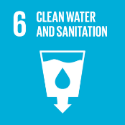

Policy Review & Validity
This Environmental Responsibility Policy becomes effective upon approval by the General Manager and remains in force until formally revised. The policy shall be reviewed at least once every year, or as necessary, to reflect regulatory updates and operational changes.
Rayzon remains committed to continuous improvement, data-driven environmental stewardship, and alignment with evolving sustainability standards to ensure measurable and accountable progress toward responsible business growth.

Last Review date: 01-01-2025 Next Review date: 01-01-2026

Approved by: General Manger

Employee Acknowledgement Form
I hereby acknowledge that I have received, read, and understood the Environmental Responsibility Policy of Rayzon. I am aware of my role in supporting the company’s environmental goals and agree to comply with the practices and procedures outlined in the policy. I understand that failure to follow this policy may result in disciplinary action. I commit to promoting environmental responsibility in my daily work and to reporting any incidents of non-compliance or environmental risk to the appropriate authority.

Employee Name: _____________________
Designation: ________________________
Signature: ___________________________
Date: _______________________________

